Materials for the exploration of intimate sensations and sexual pleasure
Material enabling reflection, awareness, and understanding
EMANUELA CORTI, Xi'an Jiaotong-Liverpool University, emanuela.corti@xjtlu.edu.cn
IVAN PARATI, Xi'an Jiaotong-Liverpool University, ivan.parati@xjtlu.edu.cn
Over the last few years, we aimed to empower humans and their bodies, connecting the self, facilitating a dialogue between people through their senses with the support of technology. In our perspective and practice, technology should be embedded in everyday life into objects that can improve aspects of a person’s daily routine, and blend into products that anyone could use, while being accessible to users with special needs. Our work takes in consideration physical, political, and societal barriers that people with disabilities are often facing, while aiming to achieve inclusive solutions. Among our projects, Lovewear, a project partially founded and developed through the European Union Horizon 2020 research and innovation program, offers an autonomous experience through haptic feedback, allowing self-exploration of intimate sensations and sexual pleasure. The natural sensation of a tactile movement on the skin’s surface is achieved through soft robotics; miniaturized pumps and solenoid valves, precisely direct and control the airflow through a matrix of isolated textile chambers. In this positioning paper we are highlighting what we have learned from this project, which is the base for our further explorations, to enable reflection, awareness and understanding of the body.
CCS CONCEPTS • intimacy • soft robotics • material development • natural sensation • tactile movement
Additional Keywords and Phrases: exploration, sex-toys, skin’s surface, textile, awareness, body sensations
ACM Reference Format:
Emanuela Corti, Ivan Parati. 2023. Materials for the exploration of intimate sensations and sexual pleasure.

Introduction

Sexuality is a human right, according to the United Nations and the Convention on the Rights of Persons with Disabilities [1], although sex, is still a taboo subject and the privilege for some individuals. Neuromuscular disorders and other motor impairments may affect one’s social and sexual life. Disabling conditions frequently include decreased sensory input, a neurogenic bowel or bladder, impaired toilet use, and decreased genital sensation. An altered body image combined with overprotective parenting and lack of independence may hinder healthy social and sexual development in young adults [2]. Media has restricted the depiction of the human form to bodies that meet the prevalent aesthetic standards and as a result, people with disabilities lack of representation. Sexuality as a source of pleasure and as an expression of love is not recognized for populations that have been traditionally marginalized in society [3]. In most cases, sexuality is neglected, avoided, or punished, although persons with disabilities have the same sexual and reproductive health needs and desires as people without disabilities; ignorance and attitudes of society and individuals can be a barrier [4].
Lovewear, a device which combines user-centred design principles with soft-robotics integrated to textile, has been developed with the objective of offering an autonomous experience through haptic feedback, allowing self-exploration of intimate sensations and sexual pleasure to females with motor impairments. A pillow interface activates an underwear garment: while caressing and touching the pillow, the wearer triggers the underwear’s inflatable inserts actuators [5].
While developing Lovewear, we mapped sex toys currently on the market, and we noted that few products can be used by a person with a disability: impaired mobility requires proper grip, comfort, and adaptability to diverse holding postures, strengths, and capabilities. Teledildonics, haptic bodysuits, and gynoids, are now realities that have transformed human interactions [6]; soon, haptic body suits could make full body, long distance, full sex, possible. In their report on the future of sex, Owsianik et al. (2018) predicted that, in the near future, people suffering from loneliness or sexual dysfunction will use sex robots for companionship and as aids to teach themselves about sex.
Figure 1: A digital representation of Lovewear.
Our interviews, surveys and focus groups [4], demonstrated that limitations in genital sensitivity and difficulty in using sex toys without assistance were the main reasons that prevented some respondents from using sex toys, even when they desired to.
While we recognize that a product like Lovewear can never replace human contact, it is not intended to do so, as its primary aim is to serve as a temporary step towards a satisfactory intimate life. The research work behind Lovewear has been a great opportunity to discover new challenges and opportunities in the field of design. We see the area of sexuality as a flourishing arena for further investigations, as disability and aging should not be seen as obstacles to healthy and pleasurable sexual life. Therefore, our aim is to develop material and products that could enhance the sexual experience.
- BACKGROUND

A healthy sexual life is important for the wellbeing of everyone, disabled or not. Almost all the survey respondents agreed that sex is fundamental in the human experience and people with disabilities have the right to live it. Moreover, for most of them, sex corresponded to well-being, meaning both physical pleasure and positive emotions; affectivity and relationships with others were also stated as very important aspects of sex. The data confirms that sexual arousal and desire are normally present among people with disabilities, contrary to the dominant collective imagination that depicts people with disabilities as infantilized, vulnerable, and ultimately asexual [3]. Disability does not affect sexual arousal. Rather, it can affect the possibility of accessing sexual experience. Reduced mobility and limited genital sensitivity were the most frequently mentioned difficulties negatively influencing the access to sexual experience, both for intercourse with a partner and for practicing self-eroticism. Lovewear (Fig. 1) is a cognitive and educational tool that empowers movement-impaired people by giving them autonomy to explore their own bodies through an interface pillow that through rough gestures controls the underwear with inflatable actuators, characterized by different patterns that stimulate various erogenous zones of a female wearer.
  - Soft robotics
Soft robotics have been recently deeply researched [7]; this project addresses their domain to the specific field of sex toys within a more inclusive scope. Soft robotics allow to overcome several Conventional robotics’ disadvantages, since soft structures are more suited for safer human interaction and can potentially reduce mechanical complexity [8]. While pneumatic systems have been a usual form of actuation since the beginning of soft robotics in the nineties [9] textile-based solution are getting attention only in the recent years [10]; the complex manufacturing methodologies of conventional elastomer materials are clear indicators of the advantages of textile-based pneumatic systems [11].
  - Manufacturing process
Through Lovewear we aimed to address movement of non-stretchable fabrics’ geometric deformation and integrating the fabric actuators as seamlessly as possible into the garment itself. Therefore, the heat press method was employed to manufacture the actuators, minimizing the device’s thickness, and exploring hinges’ integration to determine the motion [12]. Generally, a well-tested method is molded silicon, which makes the process expensive and not appropriate for industrial production. While collaborating with Fraunhofer we simplified the fabrication process using thermoplastic coated and textile-based soft actuators, reducing the production’s time and the components’ cost, obtaining a more sustainable, affordable, and democratic outcome. The Lovewear project pursues a novel concept for implementing haptic stimulation through the development and use of soft actuators embedded in knitted underwear. The further advantages of the textile-based approach are low weight, an extremely low profile at atmospheric pressure, high force/weight ratio, and simple, fast production.
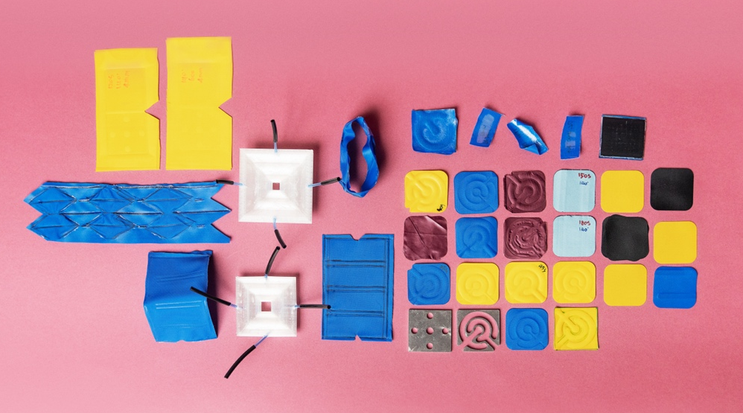
Figure 2: Material testing.
- OPPORTUNITIES
The research work behind Lovewear has been a great opportunity to discover new challenges and opportunities in the field of design. We see the area of sexuality as a flourishing arena for further investigations for what concerns soft robotics and materials.
The research led to technical considerations and biological requirements that we are considering for further explorations and developments:
- Soft robotics is still finding its way to commercial applications and one of the main barriers is to be found in the gap between prototyping and mass manufacturing techniques. The mass production of these devices poses several limitations in terms of design complexity.
- The use of liquids (water or oil) as a medium of activation for a more natural sensation should be explored.
- The design should consider electronics that are fully detachable but easy to plug in.
- The full sexual response cycle of libido, arousal, orgasm, and resolution should be considered. Sensors could collect data, either in the proximity of the vulva or on the device, such as skin temperature, muscular movements, and vaginal wetness.
- Lubrication should be considered for a better experience.
- Disposable components, through a modular approach.
- Other erogenous body parts should be considered.
- One important aspect is the adaptability to diverse bodies.
- Voice control could support control for more severe impairments but also serve as a diverse and playful interaction mode.
- Pillow could be replaced by different supports and interfaces.

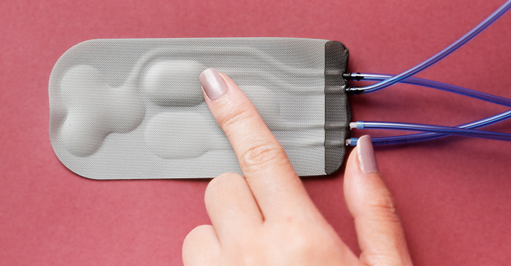
Figure 3: Inflatable textile pad.
- CONCLUSIONS
Our aim is to develop products and materials that empower body awareness, exploration and sensoriality.
We see the development of a biocompatible and biodegradable material as one of the most important opportunities to develop products to explore intimacy. Disposable, modular components would guarantee the possibility to renew and enrich the user experience extending the product life, while avoiding obvious threats to the environment. Pattern and texture could be part of the exploration to enrich the tactile experience.
REFERENCES
- United Nation, 'Article 25' Convention on the Rights of Persons with Disabilities (CRPD), 2006 < www.un.org/development/desa/disabilities/convention-on-therights-of-persons-with-disabilities/article-25-health.html>, accessed 21 March 2020.
- J. Neufeld, F. Klimgbeil, D. Bryen, B. Silverman, and A. Thomas, “Adolescent sexuality and disability,” Physical Medicine and Rehabilitation Clinics of North America 13, No. 4 (2002) pp. 857–73.
- M. Tepper, “Sexuality and disability: The missing discourse of pleasure,” Sexuality and Disability 18, No. 4 (2000) pp. 283–89.
- E. Corti and I. Parati, “Democratizing pleasure: Movement-impaired individuals’ perception of sex and the design of inclusive sex toys,” Journal of Design, Business & Technology 8, No. 1 (2022) pp. 09—37.
- Corti, E., Parati, I., Dils, C., “Lovewear: Haptic Clothing that Allows Intimate Exploration for Movement-Impaired People”, Leonardo 2023; doi: https://doi.org/10.1162/leon_a_02340
- J. Owsianik, R. Dawson, and B. Cole, “Future of Sex Report,” 2018, <www.futureofsex.net>, accessed 15 January 2019.
- A. Chen, R. Yin, L. Cao, C. Yuan, H. K. Ding, and W. J. Zhang, "Soft robotics: Definition and research issues," 24th International Conference on Mechatronics and Machine Vision in Practice (M2VIP) (2017) pp. 366--370.
- S. Kim, et al., “Soft robotics: a bioinspired evolution in robotics,” Trends in Biotechnology 31, No. 5 (2013) pp. 287--294.
- D. Rus and M. T. Tolley, “Design, fabrication and control of soft robots,” Nature 521 (2015) pp. 467--475.
- J. Xiong, J. Chen, and P. S. Lee, “Functional Fibers and Fabrics for Soft Robotics Wearables and Human Robot Interface,” Advanced Materials 19, Vol. 33 (2020) pp.1--43.
- C. Fu, Z. Xia, C. Hurren, A. Nilghaz, and X. Wang, “Textiles in soft robots: Current progress and future trends,” Biosensors and Bioelectronics 196 (2022).
- J. Ou, et al. “AeroMorph - Heat-sealing Inflatable Shape-change Materials for Interaction Design,” UIST '16: Proceedings of the 29th Annual Symposium on User Interface Software and Technology (2016) pp. 121--132.

